College year

2017-2018

Computer Science DUT

Killian Wolfger

**Internship Report**

12 weeks in a university

Host organization IT department

UFS (Universidade federal de Sergipe) Arles site

Supervisor de estágio : Tutor :

Diego Armando de Oliveira Meneses Romain Raffin

**Keywords:**

UFS ; Development ; Progressive Web App ; Gamification ; Javascript ; Vue ; Quasar ; Bresil ; English ; Portuguese

You can find the definition of the words and terms marked with a * in the lexicon

**Acknowledgments**

I would like to thanks Diego Armando Meneses my internship supervisor, Romain Raffin my tutor, Mr Sergio Araujo, and all the information science department of UFS for this warm, welcoming and motivating atmosphere. I would also like to thanks Pauline Gaston who helped in the obtention of the internship.

A big thanks to Diego Meneses who wasn’t just a internship supervisor but also a teacher who took time to lead me through all the steps of a software development process such as this one.

Nonetheless this whole project wouldn’t have came through without the great help of Mr Sergio Araujo who has my whole gratitude.

I would also like to thanks my friend’s family, the Gonçalves who generously hosted me during this internship and with who I will keep amazing memories.

**Table of contents**

**Introduction** **5**

**The University** **7**

2.1 Presentation 8

2.2 UFS in numbers 9

**Activity report** **10**

3.1 Arrival in the country 11

3.2 First steps 12

3.3 A questioning and a new start 15

3.4 What is coming next 21

Resume of competencies 22

Appreciation Letter 23

**Fourth part** **24**

**Conclusion** **24**

**Lexicon** **26**

**First part**

# Introduction

I carried out my end of year internship from the 19th April to the 6th July in UFS (Federal University of Sergipe, Brazil). This internship is cloturing 2 years of study at Arles computer science IUT. During this internship, I worked as a web developer by programming a progressive web app. Activity in which I was assisted and supervised by Diego Armando de Oliveira Meneses.

This internship have been for me a real opportunity to develop my programmer’s skills, interacts with people and different work area in a structured organisation. I had the chance to live this experience in a foreign country, which allowed me to learn portuguese and strengthen my english as well as discovering new working methods, a new culture and different ways of thinking.

First we are going to study the university and its particularities through a global presentation and in a more accurate way, with data. In a second time we are going to expose my work as well as the different tasks I was assigned.

**Second part**

# The University

## 2.1 Presentation

The Federal University of Sergipe is a [Brazilian](https://en.wikipedia.org/wiki/Brazil) public institution of higher education based in Sergipe. Currently, UFS has campuses in the municipalities of São Cristóvão (headquarter), Aracaju, Laranjeiras, Itabaiana and Lagarto, offering annual enrollment for 5.720 incoming freshmen with 117 course options. It was founded in May 15th 1968 by the junction of the State's existing [colleges](https://en.wikipedia.org/wiki/Colleges). As [traditionally seen](https://en.wikipedia.org/wiki/Universities_and_higher_education_in_Brazil) in Brazilian educational system, in which state-banked universities tend to offer better quality of education, it became the State's most reputable and disputed higher education institution, ranking among the country's 40 best universities and [Latin America](https://en.wikipedia.org/wiki/Latin_America)'s top 200.

The principal mission of the university is to contribute to the progress of the state through knowledge generation and the formation of critical, civic-minded citizens who are committed to promoting sustainable development in the region.

Concerning the informatic ressources, UFS dispose of a lot of laboratories, computers running on windows 10 that I used to document myself, I mainly did the programming part on my own computer.

## 2.2 UFS in numbers

|  |  |  |  |  |  |  |
| --- | --- | --- | --- | --- | --- | --- |
| **Campus** | **Courses** | | **Vacancies** | | **Professors** | |
|  | **2004** | **2015** | **2004** | **2015** | **2004** | **2015** |
| São Cristóvão | 39 | 85 | 1840 | 4040 | 377 | 946 |
| Other campus | 4 | 32 | 160 | 1680 | 84 | 473 |
| **TOTAL** | 43 | 117 | 2000 | 5720 | 461 | 1419 |

*Table informing the number of courses, vacancies and professors of UFS*

|  |  |
| --- | --- |
| **Area** | **Spendings (USD)** |
| Staff | 84,580,150.213 |
| Cost Benefit | 4,368,036.715 |
| Maintenance Costing | 17,291,246.60 |
| Capital Expenditures | 13,805,816.19 |
| **TOTAL** | **120,044,515.99** |

*Table of the university’s spendings by area*

**Third part**

# Activity report

### **3.1 Arrival in the country**

I landed in Brazil the 19th of April at 11 am. I’ve been welcome by Mr Sergio Araujo and a friend of mine. We ate together before going straight for the university. We did a first tour of the institution and I’ve received a very warm welcome by all the departments especially by the international relation department and the information science department.

The first week of my internship has been dedicated to my installation in Brazil,and a more thorough visit of the universitys. We visited the major part of the latter, the different departments and buildings, the laboratories, the library, the cafeteria… Concerning the university’s structure, I’ve noticed that it’s pretty similar to french ones, with the same core of departments.

The campus was really impressive, and different from ours, a lot of trees and exotic plants and a beautiful park where students can lay and chill after class.

Something that surprised me a lot was the dozen of cats walking freely in the campus, in the buildings hallways or even in laboratories, which was actually bringing a relaxing atmosphere.

I really liked the ambiance and as well as the professors, the students made me feel home since day one.

### **3.2 First steps**

During the second week we had a lot of discussions and meeting about the internship project. At the beginning it was supposed to be a web app delivering advices for students to get a job. But after some talks we decided to see bigger. We reshaped it, talking about the different technologies, version control tools, or concepts to use, the range, the aim and the content of the application.

The new project is meant to be a tinder app-like for students and companies. In a more concrete way, this app will allow students to subscribe and provide informations on their school path to look for companies in their work area. Concerning the technologies applied, the call have been made to use JavaScript, Node.js and concepts such as progressive web app* (PWA) and gamification. The gamification is the use of game concepts in non game environments, intending to perform tedious actions (like filling a form), in a fun way. We also chose to use GitLab* as versioning tool and Docker* to get a similar development environment on different computers.

This app would help the students to get involved in a job research process during their studies in which their progression could be encouraged and checked by the university. This aim, being much more ambitious and working alone on this project, I was assigned the creation of a prototype.

Even though I had started during the second week, I dedicated the third week to the learning of the technologies and developer tools, such as JavaScript, NodeJs, GitLab and Docker. I also had to document myself about all the progressive web app aspects as well as the concept of gamification. I also handled the configuration of the development environment.

This gamification concepts is really attracting and interesting to me since I already created some games myself during my DUT. On the other side I really struggled with web technologies because I was mainly doing desktop applications and I didn’t have class on JavaScript or Node js.

By the end of the fourth week I had programmed a simplified first version of the progressive web app in Vanilla* JavaScript, to test the technology and estimate its potential. We were having a meeting each week, always to talk and debate about how to improve the app, what ideas to follow and which ones to give up on. I learned a lot thanks to these weekly meetings, being permanently brought to question my development choices. A lot of matters were redondant such as the way to improve the interactivity with the user, the technologies to use or how to improve the gamification aspect. At the end of each reunion, we were scheduling the next one, and between them we were mainly communicating by whatsapp.

The Fifth week goal setted up in the previous meeting, was to reach 100 out of 100 points in the Lighthouse. The LightHouse is a chrome developer tool, which perform an analysis of your app and rate the latter according to whether or not it matches with progressive web apps concepts. By example the presence and quality of a service worker* and a manifest*, the connection delay, the display on a mobile screen and much more. Although, the lighthouse not only validates the pwa concepts, but also make an audit of the performances, best practices, accessibility and SEO (search engine optimization). It’s a very interesting and useful tool because with its results we can create an action plan to improve our app.

I struggled during the first days to understand how were working all of these new features and how to implement them. After a lot of modifications and audits, I reached the decent grade of 91 in the chrome dev tool.

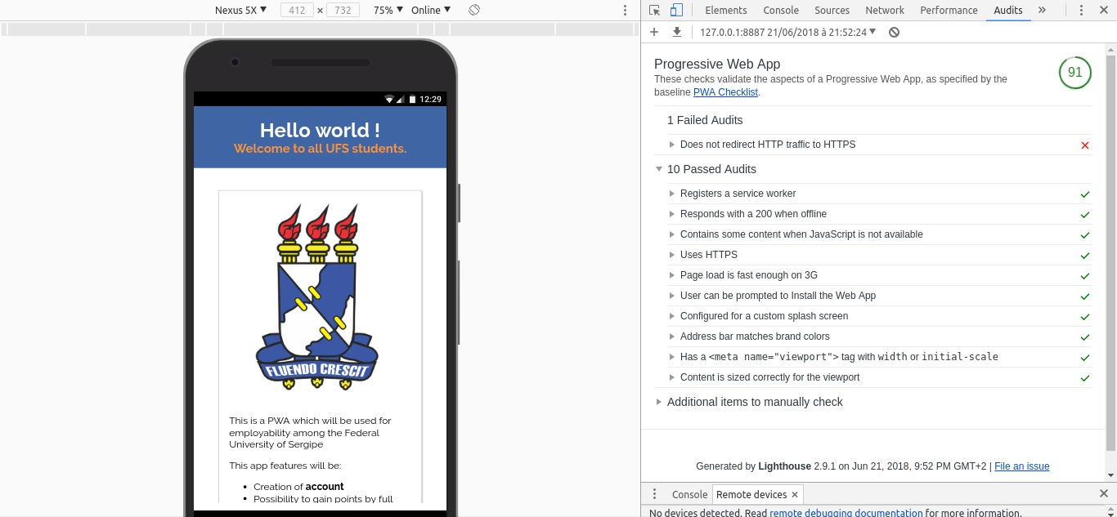

*Screenshot of the web app after an audit on the lighthouse*

I finally succeed to reached a rate of 100 by running the app on firebase* (which provide the https protocol).

### **3.3 A questioning and a new start**

At the beginning of the sixth week we had a reunion in which we talked about the future of the application. We decided to give up on a Vanilla JavaScript based app because it was too time-consuming and too difficult to master to get to the aimed design. Therefore we opted for the use of a framework* and a super framework offering boilerplates and ready to use written code.

I used the following days to research and analyse different frameworks (React, Vue.js, Angular..) to determine the more adapted. After presenting the different option in another meeting the same week, we made the call to use the framework “Vue.js” and the super framework “Quasar”, more easy of use and more adapted to the graphic design that we were aiming. I spend the rest of the week installing them and reading the documentation.

We gave up on the first app version (in Vanilla JS) and I started to program the PWA on Quasar during the seventh week while I kept documenting myself. Meanwhile, since we were focusing on the gamification and the design we decided to use the web storage* to store the user data filled in the form and not a database, longer to implement.

During the eighth week I started to change the single page application to a multi page application, dividing the subscribing process in two parts, one for the students (called candidates) and one for the companies. The main goal of this week and the following one was to focus on the gamification aspect such as a “virtual assistant”, a stepper, and a progressive bar to make a user game-like experience, by creating an interactive form.

The main problem I encountered was the use of scripts on quasar components, by exemple to link the progression of the knob (circular progress bar) to the different steps of the form, as well as handle their disposition in the vue depending on the other components and the gestion of the layouts. Quasar components are really useful and simple to use individually but harder to dispose or to make work together.

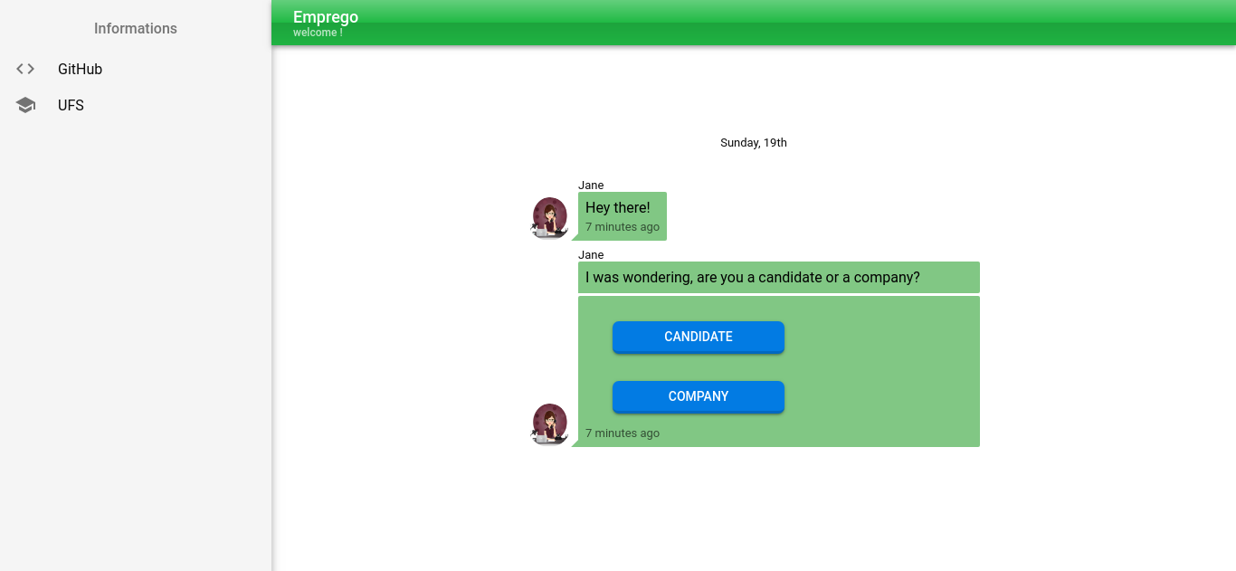

*Welcome page of the app*

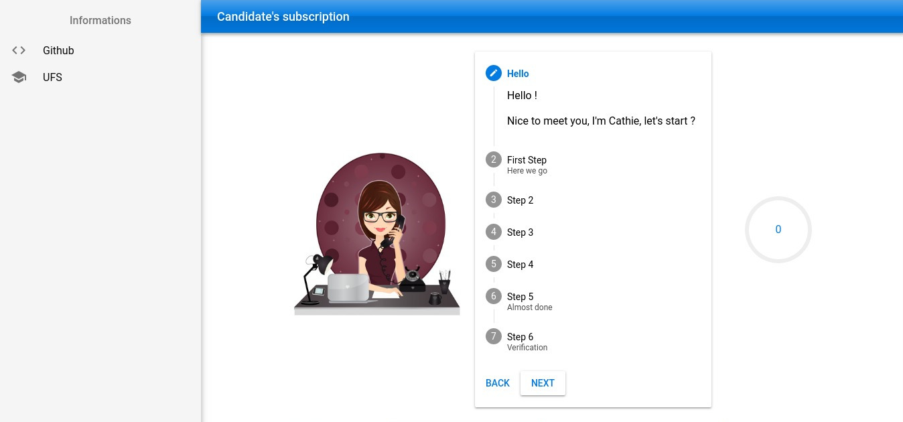

*Beginning of the candidate’s subscription*

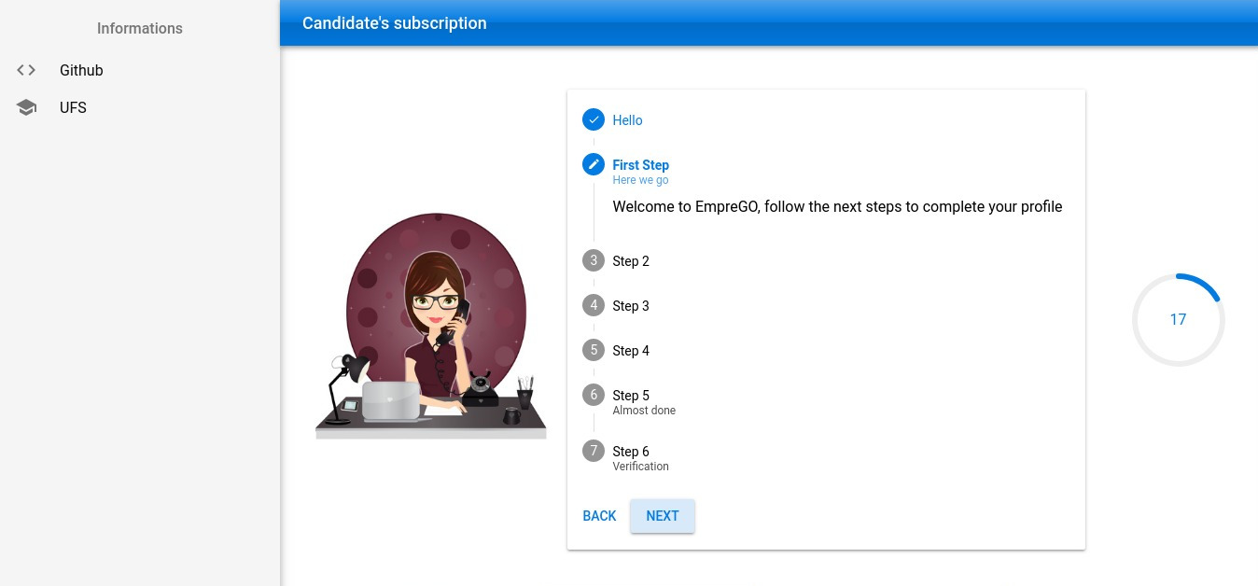

*First step of the candidate’s subscription*

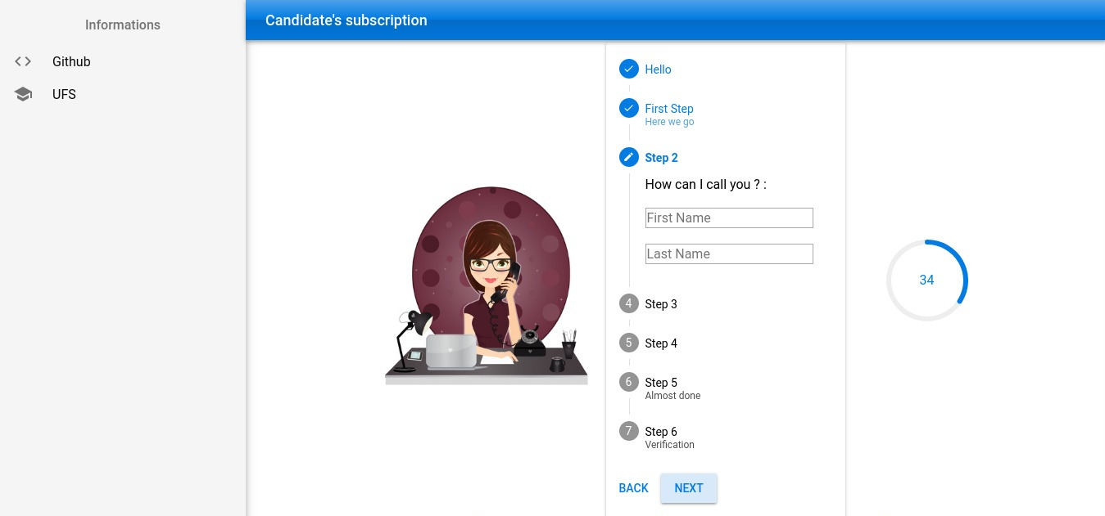

*Second step of candidate’s subscription*

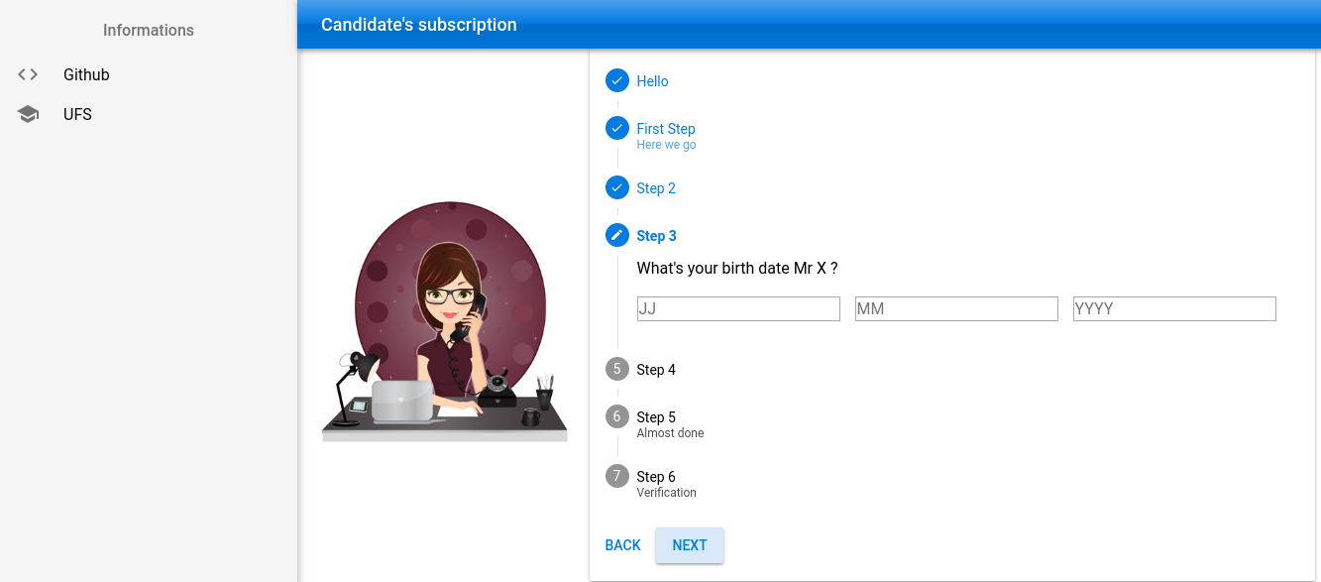

*Third step of candidate’s subscription*

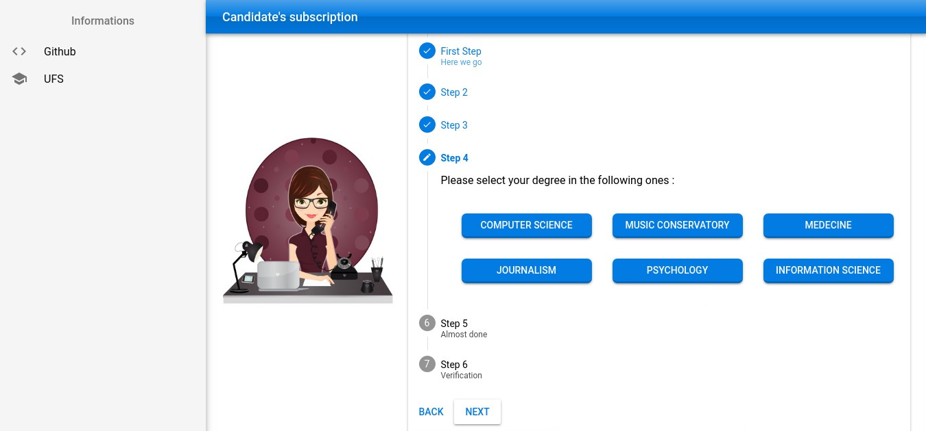

*Fourth step of the candidate’s subscription*

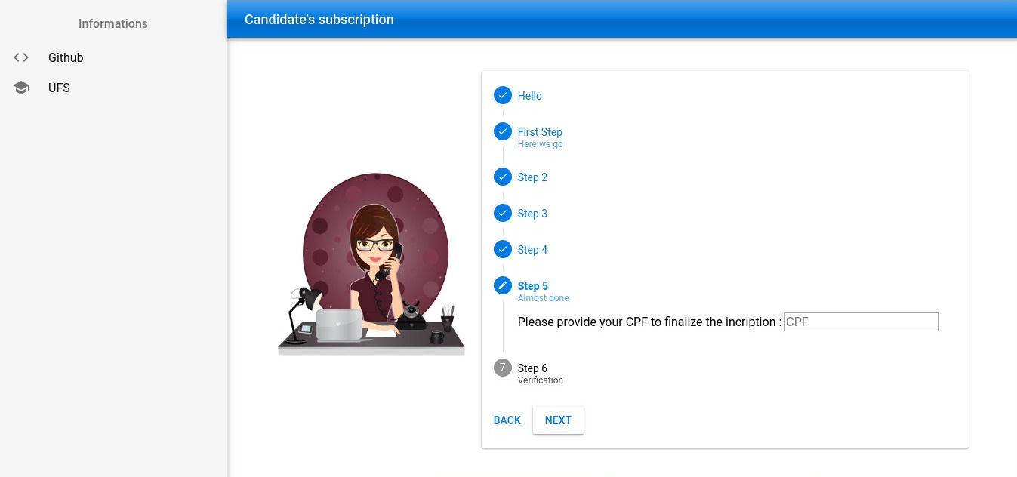

*Fifth step of the candidate’s subscription*

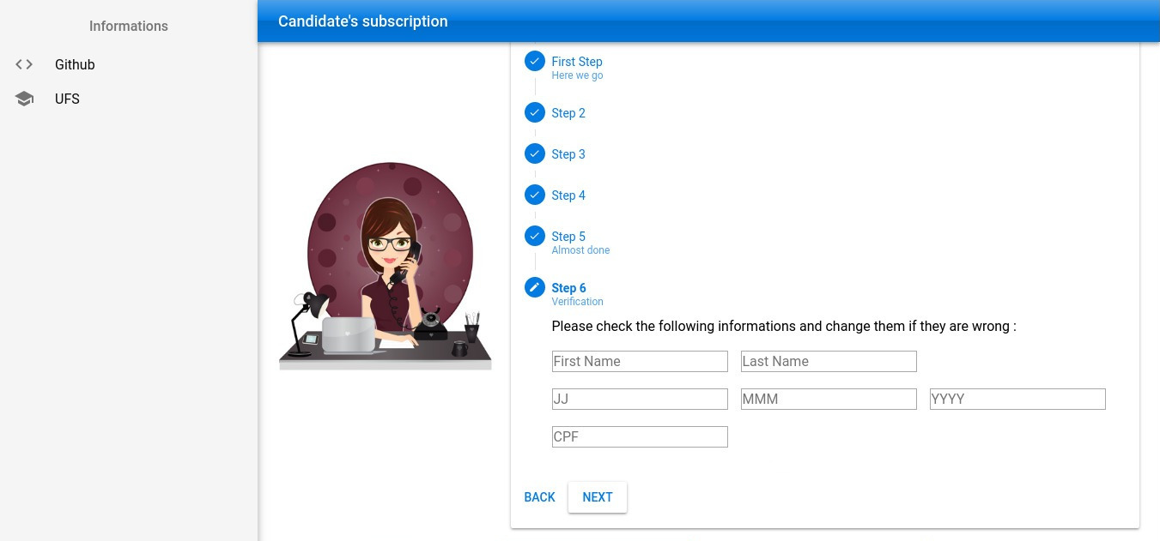

*Verification of the candidate’s informations*

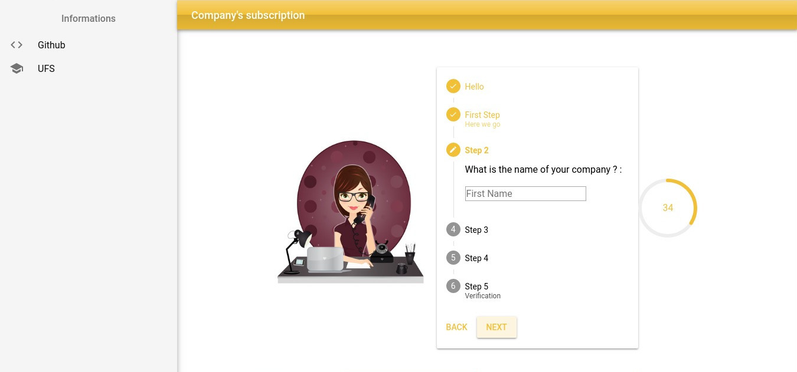

*Second step of the company’s subscription*

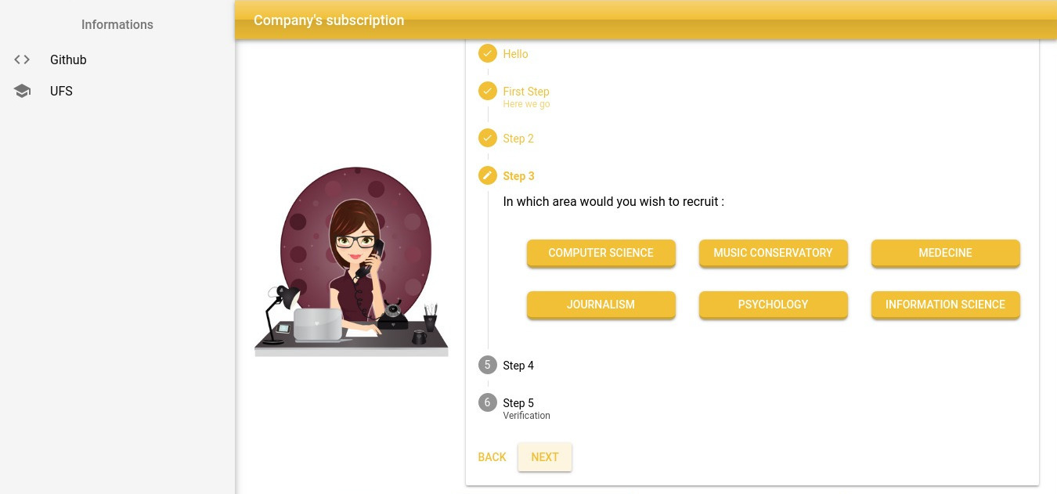

*Third step of the candidate’s subscription*

### **3.4 What is coming next**

In our last meeting we fixed the goal for the 3 remaining weeks of the internship, which is to keep improving the user interface and to create the profile pages of the candidates and the companies.

We intend to implement more gamification techniques by example a system of rewards, such as points when the user will complete his profile by providing additional informations about himself. We also plan to improve the design of the app and to think about a better way to dispose quasar components to create a more dynamic and fluid environment.

### **Resume of competencies**

This short resume of competencies have been made by my internship supervisor and teacher, Diego Armando de Oliveira Meneses.

In order to develop the trainee's professional skills, the activity of developing a web application prototype using the concepts of Progressive Web Apps (PWA) and Gamification focused on Employability was assigned.

Thus, within this activity, the trainee have known and experienced the stages of a software development process (analysis, design, implementation, tests, etc.), and used code version control tools (Git and Gitlab) that are a important characteristics for the current job market. As this develops the sense of sharing and teamwork, he has been brought to create and configure development environments (Docker, nodejs and frameworks as vue JS and QUASAR). He had to study and apply basic concepts of development for WEB (HTML, CSS and Javascript), as well as advanced concepts of WEB (Single Page Application - SPA and Progressive Web Apps). He also learned and used technological tendencies like Gamification in the solution of real world problems like Employability, develop interaction with people and thereby better creative ability and ability to perform tasks.

# 

### **Appreciation Letter**

Exmo. Mr. / Mrs.

I hereby declare my appreciation for the professional qualities exhibited by Mr. Killian Wolfger. During this internship I was responsible for overseeing the work of Mr. Killian Wolfger while performing the functions of software developer.

In this period of time I have found that Killian Wolfger is a competent and hardworking trainee, regardless of the tasks assigned to him within the main activity. I also emphasize that he is a trainee who accepts and faces challenges, is committed to schedules and engaged in his tasks.

It would highlight qualities of ease in learning, easy communication and proactivity to research how to develop the tasks, as main attributes.

Yours sincerely, Diego Armando de Oliveira Meneses

# Fourth part

# Conclusion

It was really a challenge for me to do this internship in a foreign country such as Brazil, to be dived in a completely different environment and to discover a new culture as well as new language.

Throughout this trip, I’ve learned a lot, concerning the language, the different way to think, but also on a human level. I meet very different and amazing people, discovered new habits and customs. I was immersed in a different lifestyle and vision of the world. I really enjoyed those weeks spend in Brazil, allowing me to have a vision of the things and a grasp of the world much more thrived than at my departure. It also allowed me to reached a decent level in portuguese because I was most of time in contact with people who don’t speak english, notably the friend and the family I’ve been living with, but also the major part of UFS’s employees.

During this internship I had the opportunity to learn new technologies and many times I have been brought to question my choices. I was also taking part on every decision about the project, which allowed me to have a better understanding and experience of teamwork, and to better get the importance of the calls on the further development. I’m really thankful to Mr Diego Meneses who made my learning a priority by making me go through every steps of a software development process. He let me made mistakes to learn from them and to develop a more critical mind in my future projects.

It was really an instructive experience which also helped me to clarify my professional future. I may not intend to choose the way of web developer but I found the progressive web app a very interesting concept and I believe that this area that will keep getting bigger and bigger in a near future. However, I’m thinking more and more about studying and working abroad because I loved this trip during which I lived things I would have never experienced by staying home. I’m really interested by how other cultures works, and it’s very instructive to talk, exchange and live with people from a completely different environment and background.

All of this to say that this internship is the most instructive experience I ever lived and I’m really thanksfull to had that chance, once again, thanks to everyone who took a part on it.

# Lexicon

**Docker** : [Docker](https://github.com/docker/docker) is a tool designed to make it easier to create, deploy, and run applications by using containers. Containers allow a developer to package up an application with all of the parts it needs, such as libraries and other dependencies, and ship it all out as one package.

**FireBase :** Firebase is a set of hosting services for any type of application

**Framework :** A software framework is a software providing generic functionality like additional user-written code (boilerplate) to make the development easier and faster.

**GitLab** : GitLab is a versioning tool such as GitHub but offering a different interface more adapted for teamwork.

**Manifest :** The web app manifest is a JSON file that tells the browser about your web application and how it should behave when 'installed' on the users mobile device.   
A typical manifest file include information such as the app name, icons it should use, url it should start at when launched, and more.

**Progressive Web App (PWA) :** A progressive web app is an app which put together the rapidity, security and accessibility of website with native app-like user experience.

**Service worker :**  A service Worker is a script that works independently on browser background without user interaction. Also, It resembles a proxy that works on the user side. With this script, you can track network traffic of the page, manage push notifications and develop “offline” web applications

**Vanilla Javascript** : Vanilla Js s is just a way to refer to native standards-based, and non-extended JavaScript (without the addition of libraries or frameworks).

**Web Storage :** With web storage, web applications can store data locally within the user's browser.

Before HTML5, application data had to be stored in cookies, included in every server request. Web storage is more secure, and large amounts of data can be stored locally, without affecting website performance.

I Diego Armando de oliveira Meneses, professor at the Federal University of Sergipe (UFS) and internship supervisor for student Killian Wolfger, I confirm that I have read and approved the student's traineeship report.